DESIGN AND IMPLEMENTATION OF AN AUTOMATIC LIQUID DOSING SYSTEM

KADRİ EMRE ORGUN

ÖMER YÜCE

AYBERK KILLI

HAYDAR BARIŞ ÖCAL

THE ADVISOR: SERKAN DOĞANAY

**Supply of Materials, Redesigning of Mechanism and Assembly**

Materials which we took from the lab:

* 4x guide shaft end connector parts
* 2x 350mm guide shaft
* 2x linear bearings

We used the guide shafts for linear movement. We used linear bearings to make the movement of the plate smoother. For this we rearranged our plate design in Solidworks.

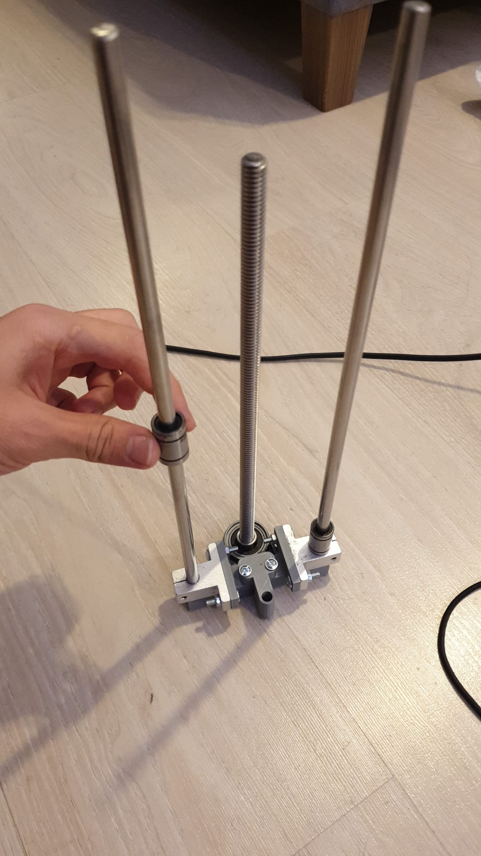

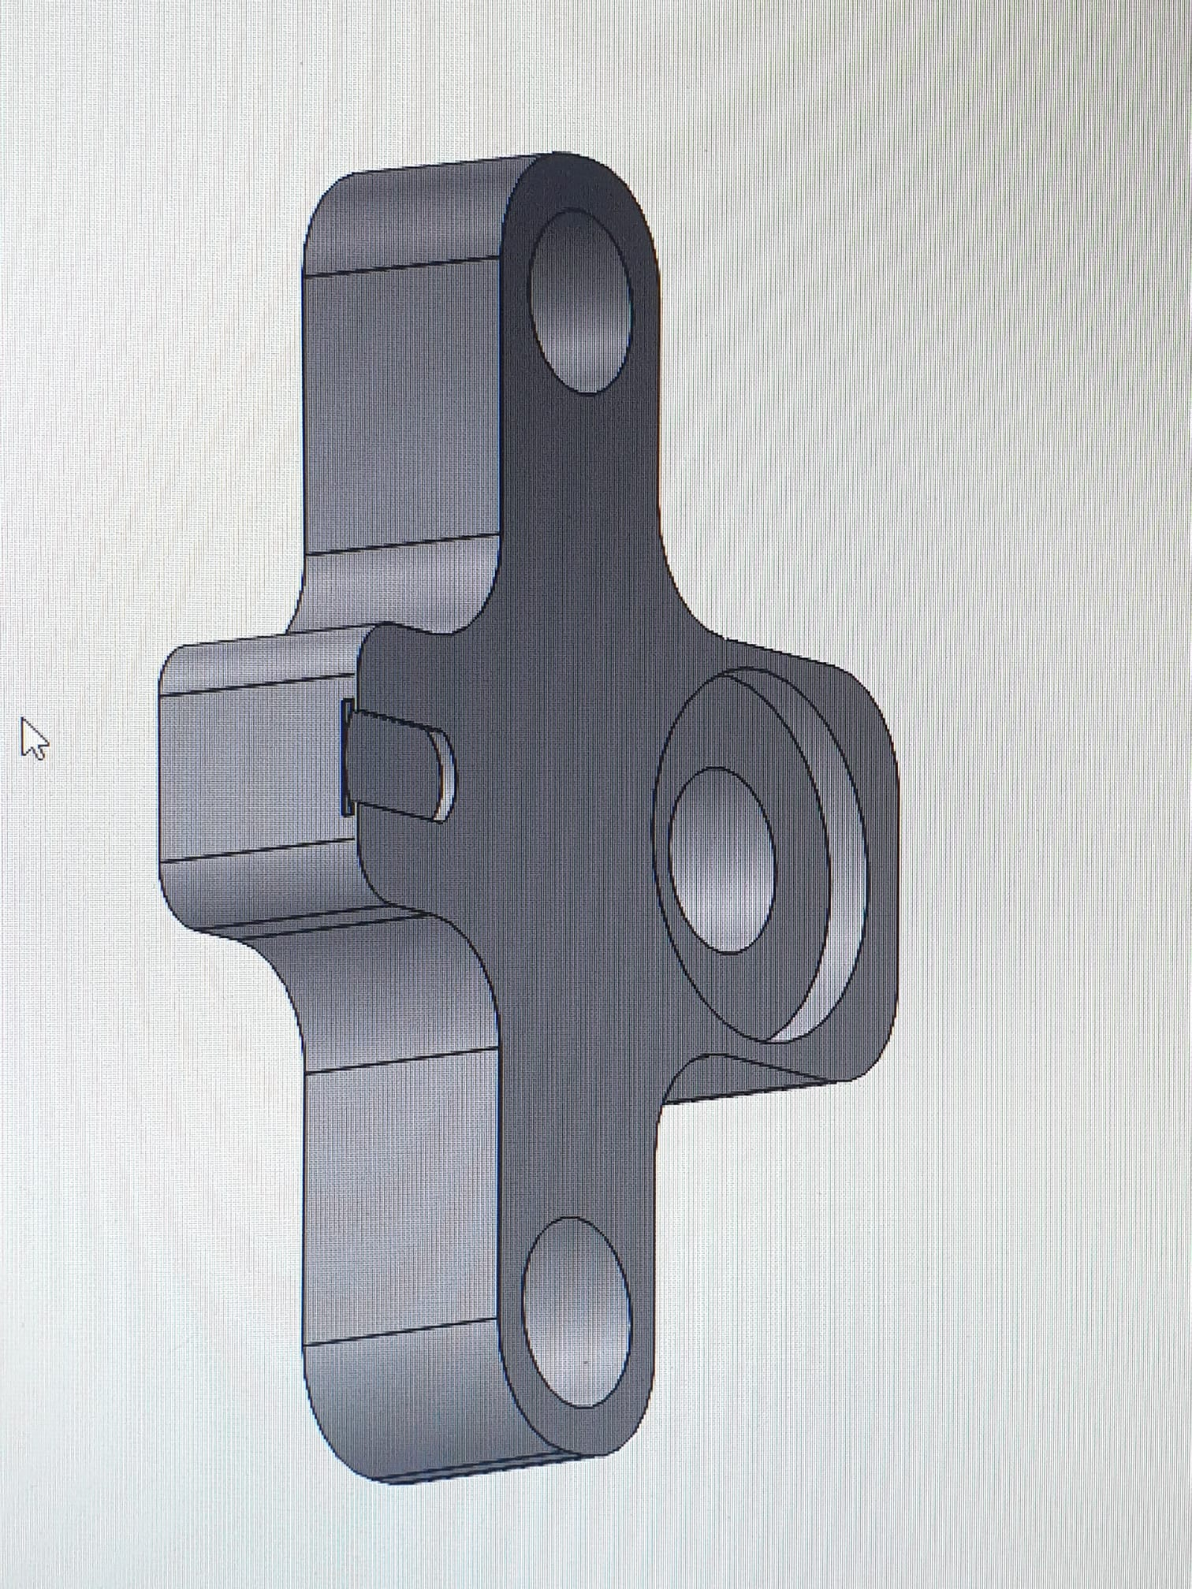

We have renewed our design to make the tip of the syringe more stable.

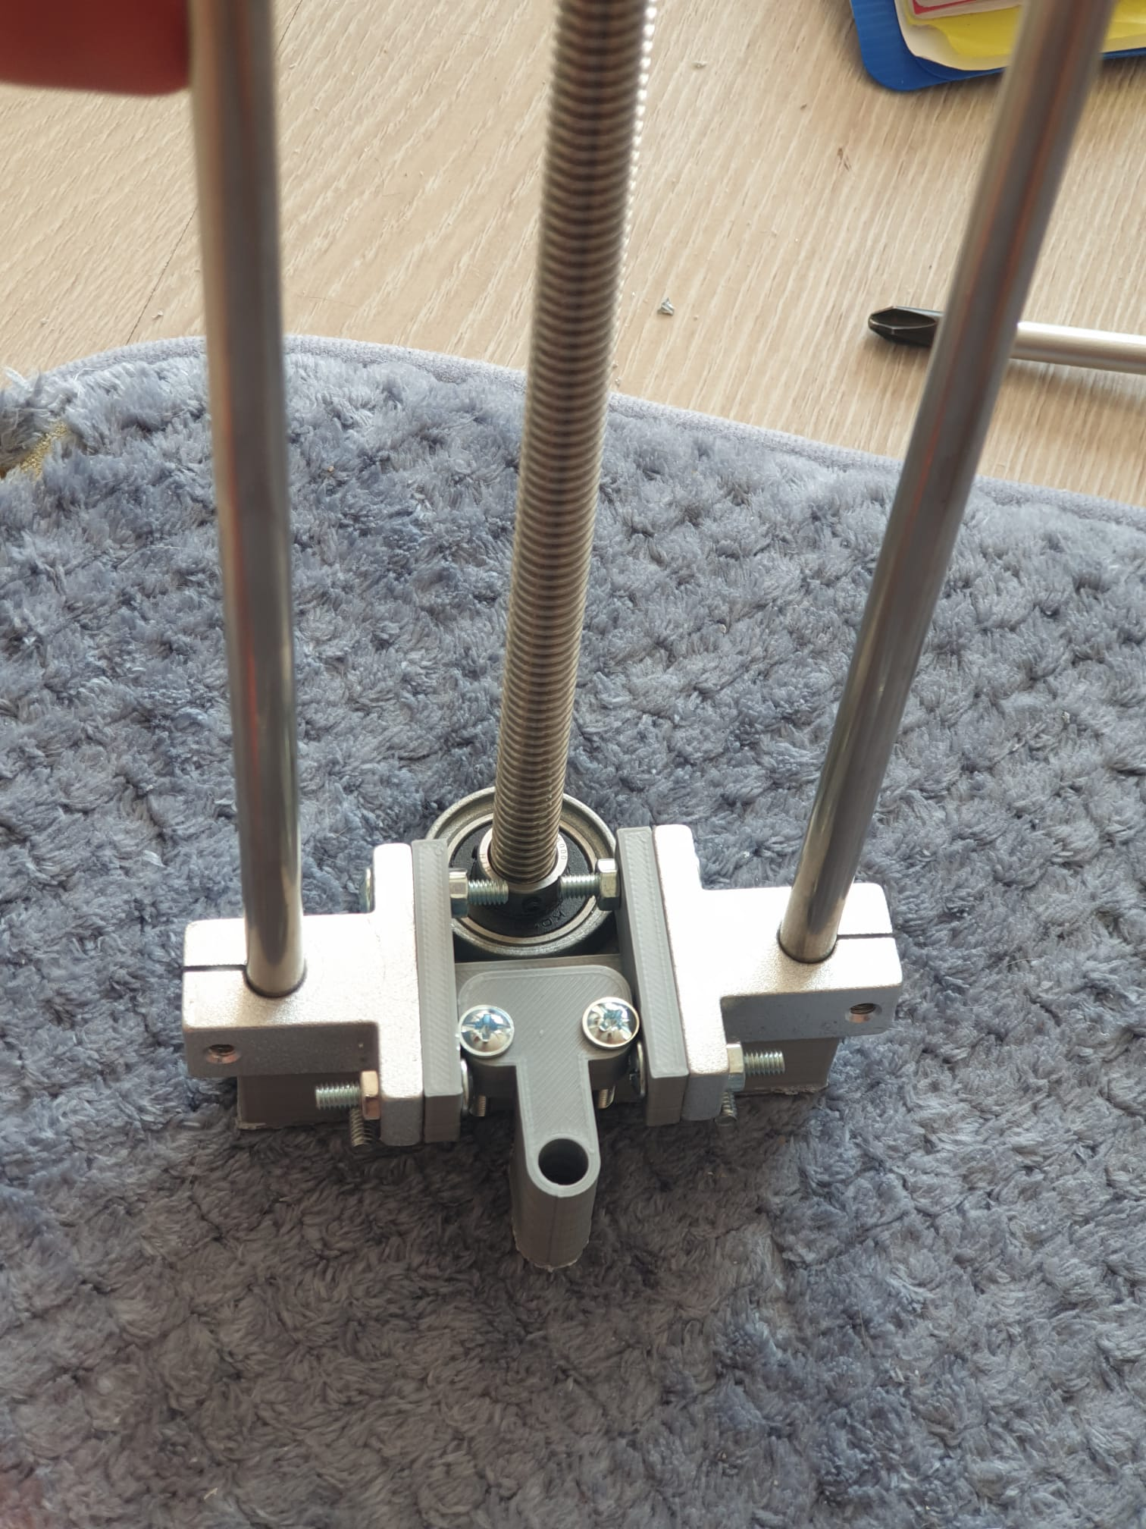

We tested the force sensor we will use and designed a place to put it in the solidworks drawing.

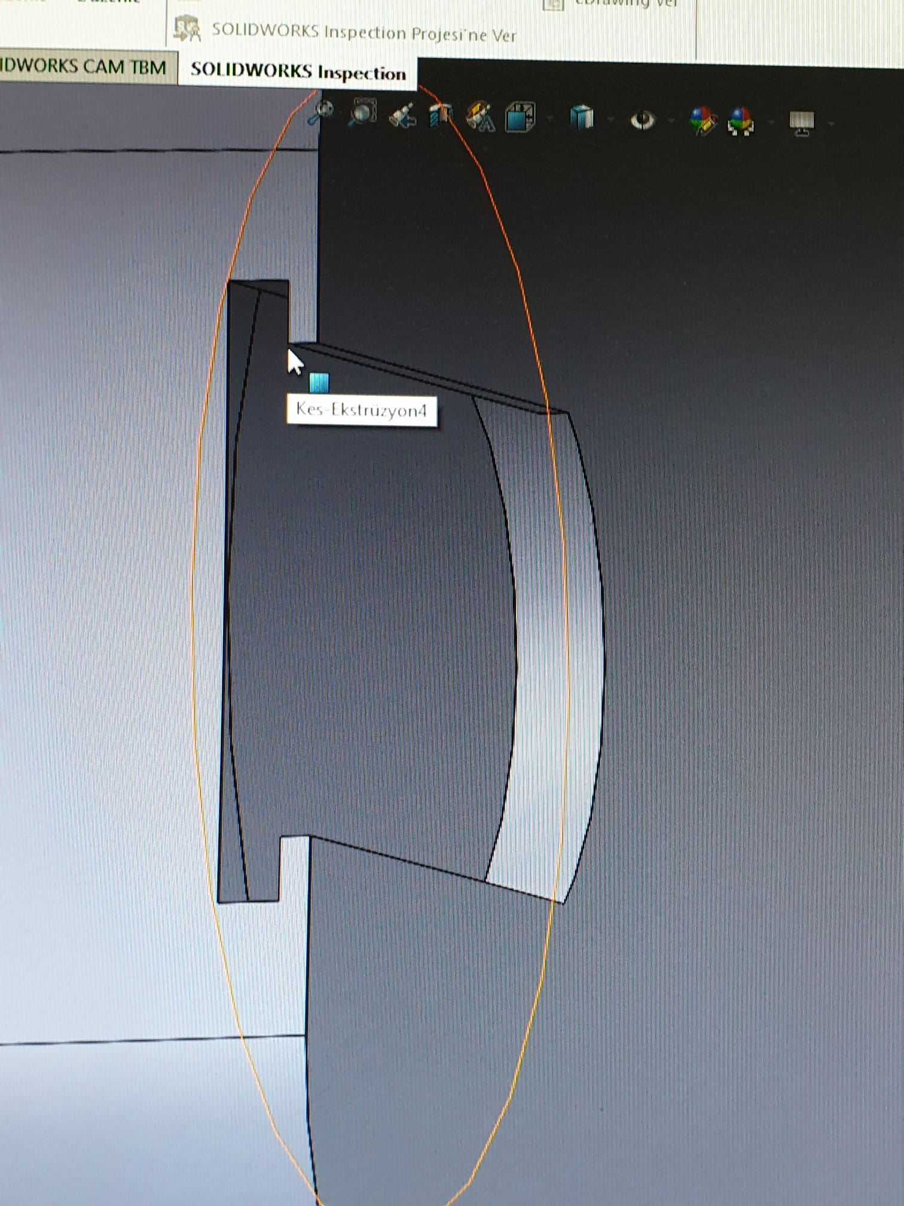

**The code that we used to test this force sensor:**

int fsrPin = 0; // the FSR and 10K pulldown are connected to a0

int fsrReading; // the analog reading from the FSR resistor divider

void setup(void) {

// We'll send debugging information via the Serial monitor

Serial.begin(9600);

}

void loop(void) {

fsrReading = analogRead(fsrPin);

Serial.print("Analog reading = ");

Serial.print(fsrReading); // the raw analog reading

// We'll have a few threshholds, qualitatively determined

if (fsrReading < 10) {

Serial.println(" - No pressure");

} else if (fsrReading < 200) {

Serial.println(" - Light touch");

} else if (fsrReading < 500) {

Serial.println(" - Light squeeze");

} else if (fsrReading < 800) {

Serial.println(" - Medium squeeze");

} else {

Serial.println(" - Big squeeze");

}

delay(1000);}

As we can see in the code, it gives different outputs for different pressure inputs. We will combine this code with the previous code and make adjustments to stop the syringe.

**Gantt Chart**

We have drafted the timeline of the project.

